**Lesson 3 – Tutorial**

1. Create an external CSS files to highlight the styles used by the HTML documents.

**Home.html**

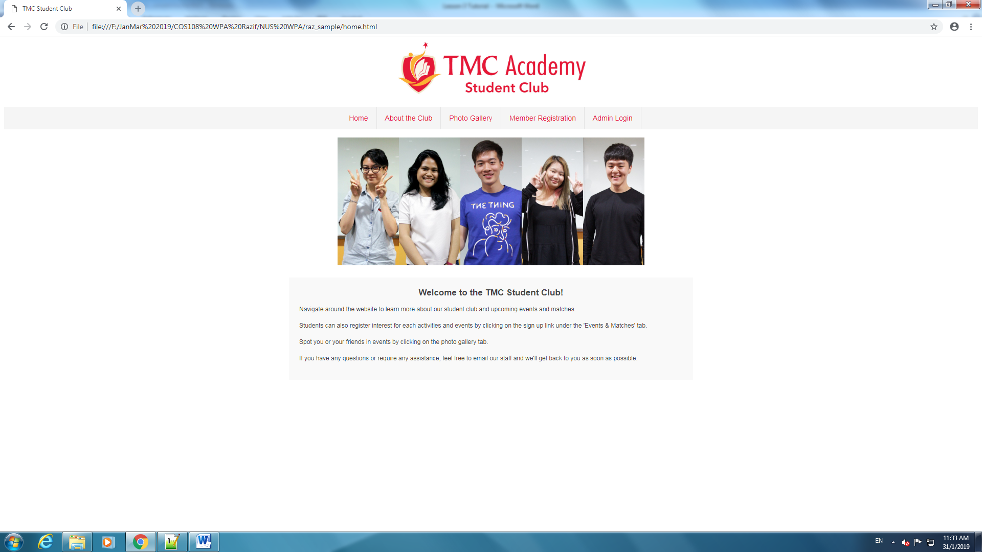

**About.html**

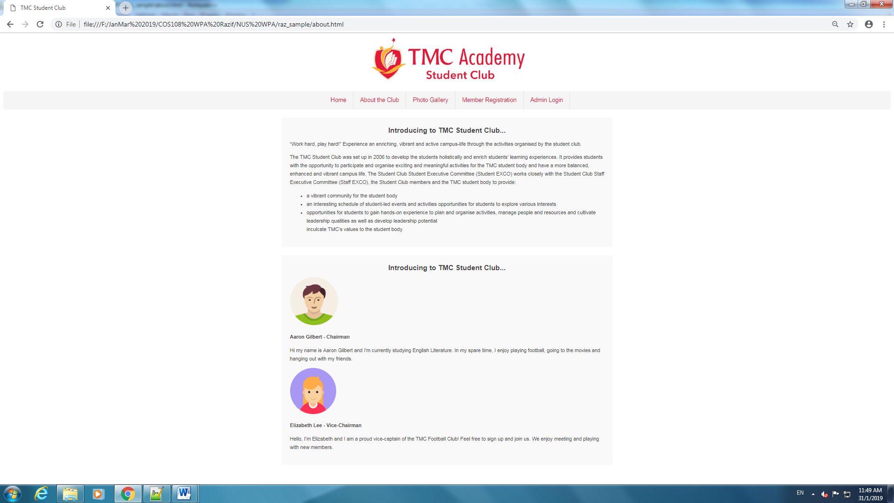

**Photo.html**

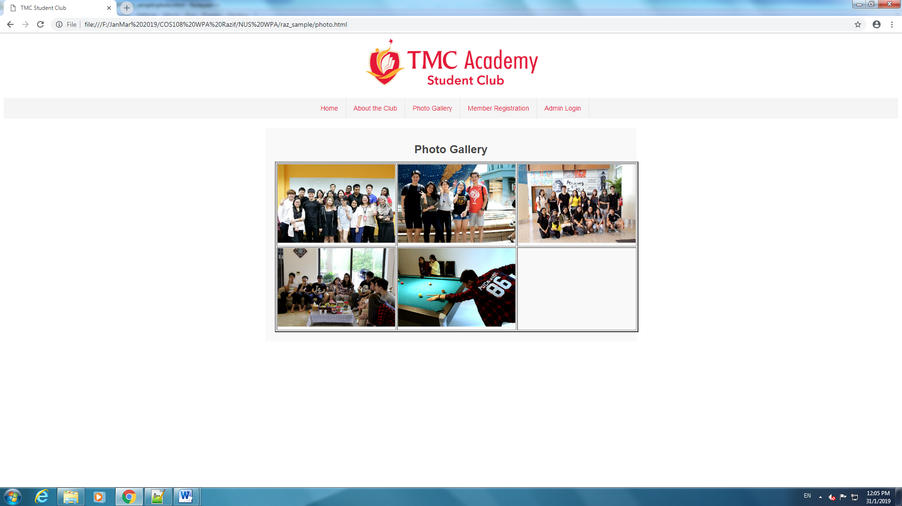

**Registration.html**

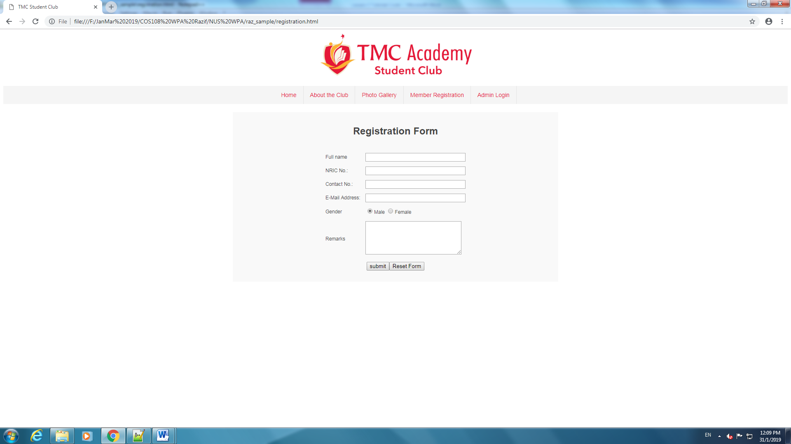

**Login.html**

